**VPC PEERING:**

1. CREATE 2 VPC’S -NAME IT AS VPC-1 & VPC-2
2. CREATE INTERNET GATEWAY – ATTACH INTERNET GATEWAY TO VPC-1
3. CREATE PUBLIC & PRIVATE SUBNET IN VPC-1
4. CREATE PRIVATE SUBNET IN VPC-2
5. CREATE ROUTE TABLE FOR PUBLIC SUBNET IN VPC-1
6. IN ROUTES, SELECT INTERNET GATEWAY ID -SAVE
7. IN SUBNET ASSOCIATION -SELECT PUBLIC SUBNET -SAVE CHANGES
8. CREATE ROUTE TABLE FOR PRIVATE SUBNET IN VPC-1
9. IN SUBNET ASSOCIATION -SELECT PRIVATE SUBNET-VPC-1 -SAVE CHANGES
10. CREATE ROUTE TABLE FOR PRIVATE SUBNET IN VPC-2
11. IN SUBNET ASSOCIATION -SELECT PRIVATE SUBNET-VPC-2 -SAVE CHANGES
12. CREATE PEERING CONNECTION -IN SOURCE- MENTION VPC-1 ID -IN DESTINATION MENTION VPC-2 ID
13. CREATE SECURITY GROUP FOR VPC-1- ALLOW SSH , ICMP
14. CREATE SECURITY GROUP FOR VPC-2- ALLOW SSH , ICMP
15. CREATE PUBLIC INSTANCE IN VPC-1
16. CREATE PRIVATE INSTANCE IN VPC-1
17. CREATE PRIVATE INSTANCE IN VPC-2
18. LOGIN TO PUBLIC INSTANCE IN MOBOXTERM
19. PING ENTER IP OF PRIVATE INSTANCE -VPC-1
20. DRAG AND DROP KEY
21. GIVE READ ONLY PERMISSION TO THAT KEY CHMOD 400 1-CLICK
22. ENTER TO PRIVATE INSTANCE OF VPC-1 FROM PUBLIC INSTANCE OF VPC-1 USING SSH COMMAND
23. IN PRIVATE INSTANCE OF VPC-1 – DRAG & DROP KEY OF PRIVATE INSTANCE OF VPC-2
24. GIVE READ ONLY PERMISSION TO THAT KEY CHMOD 400 1-CLICK
25. PING ENTER IP OF PRIVATE INSTANCE -VPC-2
26. ENTER TO PRIVATE INSTANCE OF VPC-2 FROM PRIVATE INSTANCE OF VPC-1 USING SSH COMMAND

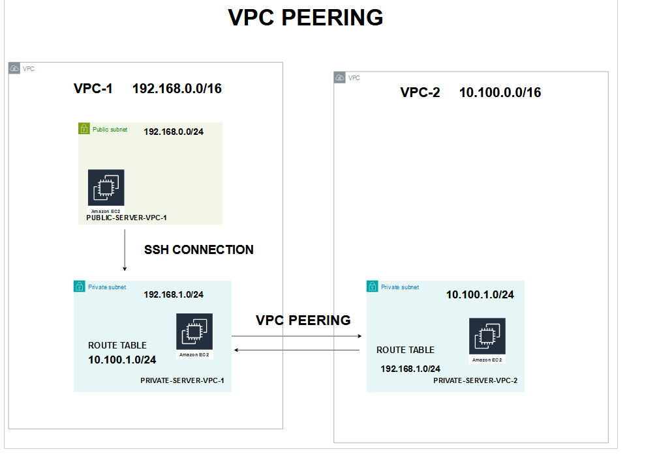

**10.100.1.0/24**

**10.200.1.0/24**

**10.100.1.0/24**

**10.100.0.0/24**

**10.200.1.0/24**

**10.200.0.0/16**

**10.100.0.0/16**

